Blockchain-based secure edge service migration mechanism Using Mobile-Agent

Abstract: In the era of the Internet of Things driven by 5G networks, Mobile Edge Computing has become an effective solution to meet the energy efficiency and latency requirements of Internet of Things applications. In the MEC system, services can be migrated from different edge servers to edge nodes closer to users, so as to ensure high quality of service. How to make the service follow the user (the edge service maintains continuous service as the user's geographic location moves) is critical. Most current research is to reduce the time cost of the edge service migration process by optimizing virtual machine and container migration. However, few studies have focused on the heterogeneity and security of the network during the migration of edge services. This article innovatively proposes a secure edge service migration mechanism based on blockchain. At the same time, it uses a mobile agent that is different from VM and container. As a carrier of edge services, it is more flexible. Finally, the service migration security issue of multiple edge clouds can be solved by using blockchain technology to maintain a trusted alliance chain. We also propose a service migration decision algorithm to seek a migration strategy that maximizes returns and to ensure higher service quality for users. Through experimental simulation and comparison, the proposed edge service migration mechanism has low latency and better user experience. At the same time, the service migration is performed in a secure and trusted environment, which provides security guarantees for edge services.
Keywords-component: Mobile Edge Computing; Service migration;Blockchain;Mobile agent;IOT

1 introduction

With the rapid development of mobile Internet and Internet of Things technology, various new services have been continuously emerging, and mobile communication traffic has experienced explosive growth in the past few years. Mobile applications using cloud computing technology are becoming increasingly popular, such as data streaming, real-time video, 3D games, and more. The architecture of applications is mostly a combination of front-end components and back-end components on mobile devices. The back-end components provide additional data analysis and processing functions through a centralized cloud computing center [1]. This approach brings great convenience to people's lives, but at the same time, the gradual complexity and diversification of services have increased network overhead and raised higher requirements for network bandwidth and latency. The concept of Mobile Edge Cloud (MEC) has recently become a promising technology to solve these challenges [2]. According to IDC's forecast, by 2020, the total amount of global data will be greater than 40 zettabyte (ZB), and 45% of the data generated by the Internet of Things will be processed at the network edge [3, 4]. The core idea of MEC is to make computing closer to users. Small servers or data centers that can host cloud applications are distributed throughout the network and directly connected to entities at the edge of the network (such as cellular base stations). By sinking the power of the cloud to edge devices, a new computing paradigm is formed that brings real-time response, analysis, and action capabilities to user applications, especially in areas with limited network conditions or lack of networks [5]. Because edge servers are very close to mobile terminal users, they can provide higher quality of service(QoS) than traditional cloud platforms. As a result, the end-user experience using cloud services will achieve higher bandwidth, lower latency, and stronger computing capabilities [6].
However, one of the key challenges facing mobile edge computing is: how to implement service migration dynamically. Due to the limited range of a single edge cloud and the frequent movement of terminal devices (such as smart cars, personal mobile terminals, etc.) to different geographical areas, the quality of edge cloud services has declined sharply, even service is interrupted which makes it difficult to guarantee service continuity [7]. Namely, how to ensure that "services follow users”. As shown in Figure 1-1, the user uses services provided by Edge Cloud A (such as augmented reality, connected car applications, etc.) at Location 1. When the user moves to Location 2, because Location 2 is not within the service capabilities of Edge Cloud A which makes it difficult to guarantee the quality of the service or even interrupt it. To ensure the continuity of services, services need to be migrated to edge clouds (such as edge cloud D or edge cloud E) near the current user location, so that services can be seamlessly migrated between multiple edge clouds. On the one hand, when the terminal user moves, ideally the services on the edge server should also be migrated to a new nearby server in real time. Therefore, effective dynamic service migration is essential for the normal provision of edge services in edge computing environments [8].On the other hand, edge services are located in different edge clouds, and edge servers may belong to different participants, such as telecommunications operators, Internet companies, and home users. Therefore, there is no centralized management for different heterogeneous hardware [9]. The dynamic, open, and collaborative nature of the MEC network environment makes network security issues more and more complex. Therefore, the issue of trust in service migration is also very important.
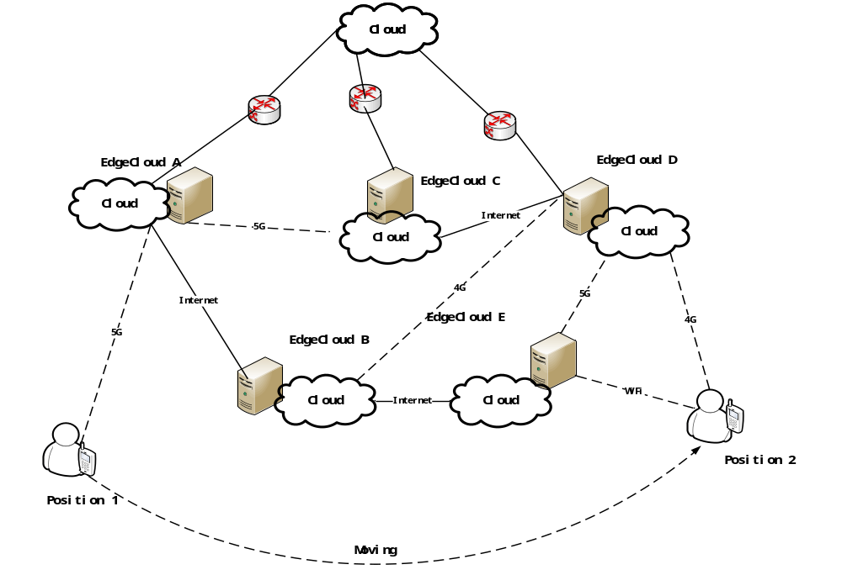
Figure1-1 Service migration scenario in MEC

In order to solve this problem, [10] introduced cognitive computing technology to edge service migration, and proposed a new computing model for edge cognitive computing (ECC) combining edge computing and cognitive computing. A practical platform for dynamic migration of edge services based on mobile user behavior cognition is established. This platform can provide higher quality of experience(DoE) and realizes user behavior prediction, which can better guide service migration based on traffic data and network resource environment. In order to solve the problem of edge service migration, [11] uses reinforcement learning model to determine migration strategy and communication strategy. However, most of the above studies on edge computing use virtual machines as the carrier of migration. The size of the virtual machine overlay can be tens of megabytes or hundreds of megabytes, and the amount of migration data is large. For delay-sensitive applications, the total migration time is relatively long [12]. What’s more, the virtual machine overlay is not easy to maintain which limits the application in industry and academia. In addition, these studies did not consider the migration trust of edge services in different edge clouds. Edge computing environments cause security risks when data is sent to untrusted edge servers. The complexity of the mechanism and the huge amount of calculation make it difficult to overcome.
In this paper, we innovatively propose a blockchain-based edge service migration framework, which uses a more flexible mobile agent as a carrier for edge services. At the same time, blockchain technology is used to jointly maintain a trusted alliance chain to solve the service migration trust problem of multiple edge clouds. Finally, a migration strategy that seeks the maximum benefit through the migration decision algorithm can guarantee a higher user service quality. We have deployed this framework in an experimental cluster to evaluate its performance. Evaluation results show that the framework can significantly improve work performance while avoiding excessive migration costs and ensuring the security of service migration
This paper has the following contributions:
- We propose an edge service migration framework using mobile agents and design the migration algorithm. The purpose of different migration strategies is to find a migration path with the best benefits and better service quality. Secondly, using multiple mobile agent technologies to form a carrier of complex services with each other makes migration more flexible, lighter, more autonomous, and less expensive to migrate, which ensures better service quality.
- In the absence of a trusted third party, in order to securely migrate services between multiple heterogeneous, decentralized edge cloud nodes, we use blockchain technology to ensure that the service migration process is in secure and reliable environment. The alliance chain network we build is suitable for distributed edge computing environments and can solve the problem of trust between different network devices and providers of edge services in complex edge networks.
- We have improved Ethereum's PBFT consensus algorithm. There is no need for a three-phase submission process at the checkpoint stage, which significantly reduces network traffic. Simulation results show that the improved blockchain network throughput is better than the traditional PBFT algorithm.
- We have designed a blockchain-based mobile agent dynamic service migration prototype platform and evaluated it through experiments. The results show that the proposed migration framework can meet the edge service needs of different users.
The rest of this article is organized as follows. Section 2 summarizes the related work. In Section 3, we describe in detail the mobile agent-based edge service migration architecture. Section 4 shows the mechanism of using blockchain technology to solve the trust problem of edge service migration. Section 5 makes a formal evaluation of the performance of the framework. The experimental results and performance evaluation of the agent-based dynamic service migration platform are discussed in Section 6. Finally, Section 7 concludes this paper and puts forward some problems to be solved.

2 related work
The issue of edge service migration has received widespread attention in the industry and academia in recent years. The demand for on-demand services (such as smart sensing, e-health, intelligent transportation, etc.) and issues affecting the QoS of various applications paved the way for the edge computing paradigm. Edge service migration is an important mechanism to ensure a good user experience. It has been widely used to study how to overcome network latency and reduce service interruption time in edge networks. There are already some literatures [13, 14] that have analyzed and summarized the service migration methods.
Earlier research on migration of edge services focused on the migration of virtual machines (VMs) which improve QoS by optimizing the migration time to reduce service downtime. Wei [15] combined remote loading and redirection to speed up service migration. By tracking historical access patterns, a load request list is generated to locate the service application for booting, then core code is automatically prefetched and cached. It enables running VMs to switch data access to merged image files, reducing edge service migration time. Sun [16] proposed an improved serial migration strategy and introduced a post-copy migration scheme into serial migration. The queuing model is established to quantify the performance indicators, and mathematical analysis is used to evaluate the performance of the model. It improves the hybrid migration strategy of serial migration strategy and parallel migration strategy, and improves resource utilization and QoS. The method proposed in [17] introduced low-latency access to data or edge services by introducing a distributed cloud layer composed of cloudlets ("small clouds" with low computing power) between users and the cloud. This method uses virtual machine to realize the common architecture for service migration. Nevertheless, the size of the virtual machine overlay can be tens of megabytes or hundreds of megabytes depending on the application, which is relatively long for latency-sensitive applications and it is unacceptable.
Some researchers use docker container migration for service migration. For example, L. Ma et al. Conducted in-depth research on the characteristics of the tiered storage of docker containers [18], and proposed a migration method that uses a tiered storage system to reduce file system synchronization overhead to improve performance issues during docker container migration. Most of these methods use container checkpoint technology (Checkpoint / Restore In Userspace, CRIU) [19] to restore services by sending container checkpoint data. However, the container's file system and image file size take up most of the migrated data. During transmission, all data in the storage layer and the entire file system is packaged and transferred. This method increases the overhead of network bandwidth resources without considering the heterogeneity and complexity of the edge network. When in a bad environment, it may worsen the edge network conditions and even interrupt service.
Agent-based edge service migration is a relatively new field and needs to be studied systematically. As a program that performs certain tasks instead of other programs, mobile agent can autonomously move from one host to another host in a complex network system compared to VMs and containers. The program can choose when and where to move [20]. When moving, the program can suspend running process as required, and then transfer them to another part of the network to restart or resume execution, and finally return results and messages. Figure 2-1 is a schematic diagram of a client agent moving to a remote host to receive services locally. An agent contains a computer program block that performs tasks in an agent relationship with other entities. The main code of the agent structure of IBM Aglets shown in Figure 2-2 can perform the corresponding tasks in each function. Aglets mobile agents can migrate and communicate autonomously in any java environment, so they occupy less platform resources, while VMs and containers tend to save most resources in migration services [21]. In the network, mobile agent is very suitable as the carrier of edge service migration because of its characteristics of moving between different hosts. What’s more, because agent-based service migration requires fewer edge servers in addition to providing a runtime environment and the use of autonomous agent-based application partitioning, it reduces the management burden on edge servers and mobile terminals [22]. In the process of service migration based on VM and container, management burdens rely heavily on the support of the underlying virtualization technology. On the contrary, agents greatly reduce management burden. Edge servers have limited bandwidth, unstable network connections, storage and processing capabilities, and running proxy-based applications on them will be more conducive to migration services [23].

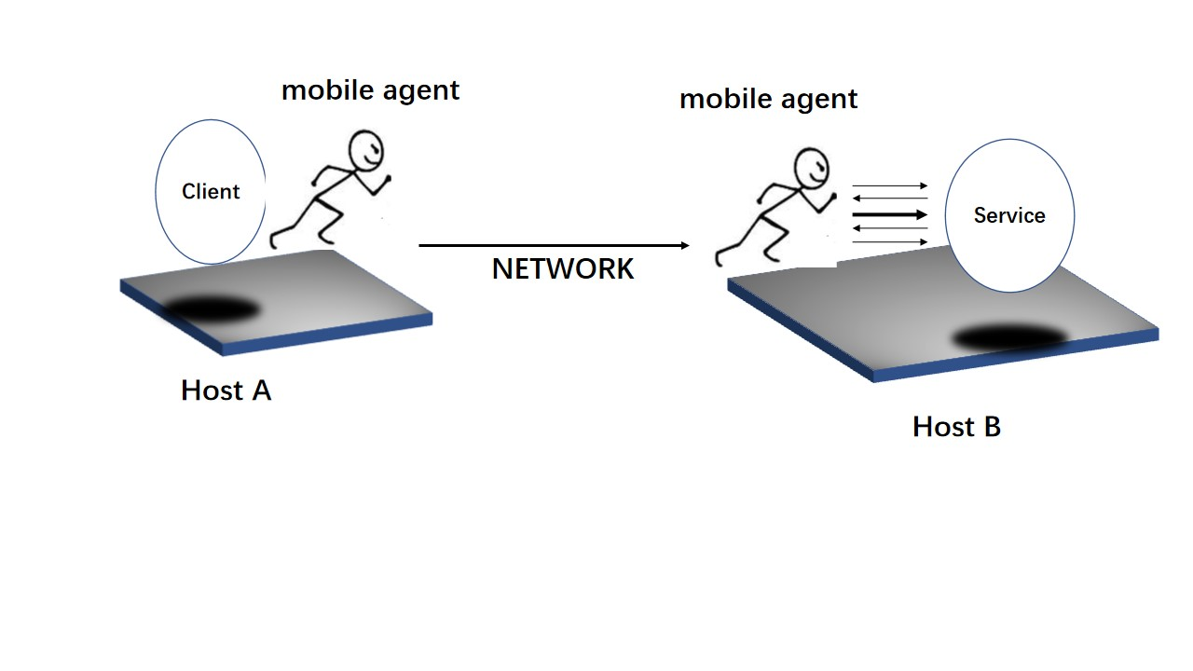
Figure 2-1 Working mode of mobile agent

import com.ibm.aglet.Aglet.*;
import com.ibm.aglet.AgletContext.*;
import java.net.*;
public class MobileAgent extends Aglet{
... ...
@Override
public void onCreation(Object init) {
//Functions to initialize information host and mobile agent resources
}
@Override
public void run() {
AgletContext context =this.getAgletContext();
... ...
//mobile agent creation
Agent= context.createAglet(new java.net.URL("url"),"MobileAgent",null);
}

Figure 2-2 The main code of the mobile agent framework

3 mobile agent system architecture
In this section, we will discuss the internal details of the mobile agent. Taking IBM Aglets as an example, this paper analyzes the advantages of mobile agents as edge service migration carriers.Secondly, we introduced the service collaboration mechanism of our system. Currently, agent technology is becoming increasingly popular and widely adopted in the industrial world [24]. However, at the time of writing, there is no systematic research into the use of proxy technology in edge services. To the author's knowledge, this is the first article to study the migration of mobile agents at edge services.(可去掉)

3.1 Migration between mobile agents
In the dynamic heterogeneous environment of MEC (such as VMs, containers, and even physical machine hosts), using mobile agents to perform service migration can obtain better performance, and have better adaptability to changing network conditions.For example, agents can migrate between VMs, containers, and physical machines as long as the Java runtime environment is configured [25,26]. This software execution environment has software and hardware support for agent operations. These resources can be a network computer, a grid node, or a cloud infrastructure in the edge network.Each agent is executed in a self-contained virtualization container. As shown in Figure 3-1, the interaction process between mobile agents is shown. Each mobile agent system consists of two parts: mobile agent(MA) and mobile agent environment(MAE).MA is a software entity running in MAE and can be migrated from one MAE to another. And interact with local services or resources to complete tasks. MA can be subdivided into User Agent (UA) and Service Agent (SA).UA can move from one MAE to another. The IBM aglets mobile agent provides different events and corresponding functions at different points in the life cycle. As shown in Table 3-1, a running aglets can call clone() Method to clone it, you can call the deactive() method to store it on a binary storage medium [27].Similarly, when the agent is successfully created and the onDispatching() method is called, the aglets agent will be dispatched to another host to continue running according to the different parameters passed [28]. When moving, the system serializes the information carried by the agent into a standard format. When the agent reaches another host, it calls onArrival() to re-run at the destination.

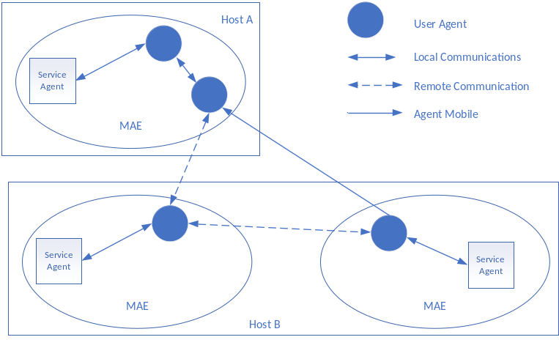
Figure 3-1 Agent interaction diagram

Table 3-1 aglets Agent events and methods
event | method
event | When the event occurs | After the event
creation |  | onCreation()
clone | OnCloning() | onClone()
dispatch | onDispatching() | onArrival()
reverting | OnReverting() | onArrival()
Disposing | onDisposing()
suspended | onDeactivtion()
Activation |  | onActivation()

3.2 Agent-based edge service migration mechanism
In our proposed migration framework, edge services are provided by a group of cooperating SAs. The agent runs on one platform at a time, but can be moved to another platform.As shown in Figure 3-2, the agent-based service migration diagram, in addition to the service agent, there are four service components: event decision server (EDS) and resource management server (RMS), data management server (DMS) and trust management server ( TMS).
EDS is responsible for collecting system-wide event and functional performance notifications and passing them to the mobile agent to decide whether the agent needs to be migrated. The agent can register for network monitoring and security events, such as calculating the network condition by analyzing the network latency RTT and packet loss rate PacketLoss parameters of the current edge server.Prevents damage to the platform on which the agent is currently running through security incident system intrusion detection. In addition, it can register to receive services offered in new platforms or announcement services for new platforms.In these cases, EDS will decide to migrate to a new platform to avoid further losses if the current platform has been damaged. We will discuss the decision migration mechanism in detail in Section 3.3.EDS is essentially the trigger source for agent migration, enabling agents to better respond to changes in the edge network environment and provide users with better QoS.
Data manager server (DMS) and trust manager server (TMS) are respectively responsible for persistently saving data (including service status data and user data) and the mobile agent's migration to the destination host for secure mutual trust data. mobile agent saves the necessary service status and data in the database before migration, and restores the status and progress of the job after migration to a trusted destination host.The migration destination edge node will maintain an alliance chain among multiple edge clouds to establish mutual trust, so as to ensure the secure migration of edge services among multiple edge cloud nodes.
Resource Management Server(RMS) is responsible for providing the required resources to agents and platforms. On the one hand, each agent functionally requires a set of resources(such as software modules, data storage, user interface, and various other functions such as virtualization, networking, and security),and the agent also has minimum requirements for each resource.On the other hand, the platform running the agent needs to have the ability to provide a certain number of resources, thereby providing a set of resources to support the function of the agent operation.Each platform can publish resources based on the quality of service provided by the RMS, and an agent queries the resources and determines whether a platform can support the necessary resource conditions necessary for its operation. If the current platform cannot provide the appropriate resource support for the agent, the agent must query the RMS to determine a viable platform to migrate to.
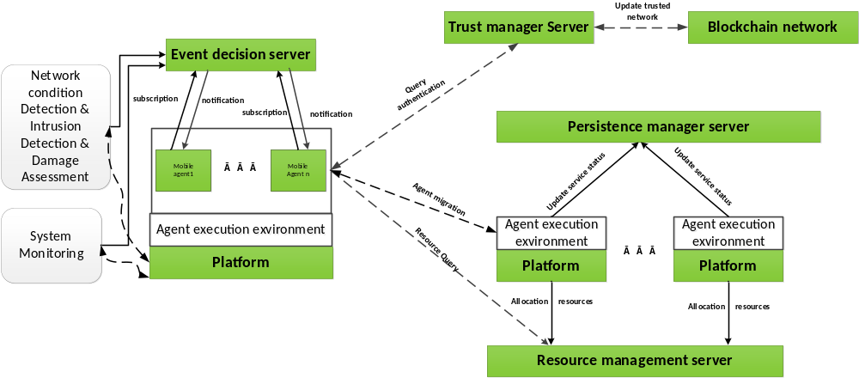
Figure 3-2 Framework diagram of agent-based service migration

3.3 Service migration decision algorithm based on mobile agent
In this section, we will discuss the migration decision algorithm based on mobile agent in detail. As we discussed earlier, mobile agent migration begins with a notification from the EDS, which involves factors such as excessive load on the edge server that is currently running the agent, or poor end-user quality due to the movement of end-user locations [29].The reasons for the migration also include: the current platform is severely damaged or it is detected that the current platform cannot provide the required services. EDS must decide which possible platforms to migrate to. In general, the target node to which the task chooses to migrate mainly considers the following factors: network carrying capacity, processing capacity, memory space, migration experience, and subsequent node information of the current node information. But these factors are complicated, and there is a certain relationship between each factor.
In our framework, deploying a sensing module on each edge server node can collect information on the network dynamic load , cpu computing power β, memory spaceλ, and migration experience γ.The edge nodes are connected to each other to form an undirected connection graph. G is connected to the current node and all weighted link arc sets, and each link arc has a migration weight Q. Combining the above several factors, we have given the calculation formula definition of the migration weight Q.
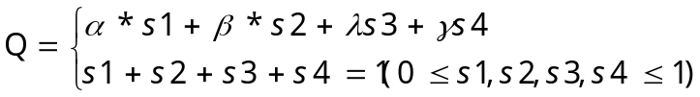 （1）
Q is the migration weight. The larger the value, the more likely the task of the current node is to move to the neighboring node. Among them, s1, s2, s3, and s4 are used as weight coefficients corresponding to the four indexes.Due to the complexity of the edge network environment, problems such as unstable network bandwidth and edge node failures frequently occur. In order to improve the adaptability of the migration process in the mobile cloud computing environment, we take into account the task weights and the network conditions of the nodes, and calculate more universal migration weight parameters.The distance between nodes is closely related to the network condition. In the definition of the distance between edge nodes, we have considered the network bandwidth and the quality of the network transmission. The node distance is shown in formula (2).
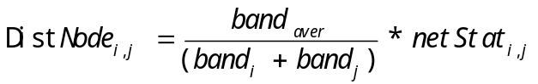 （2）
In Formula 2, 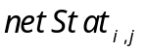 is a communication status value between the physical node 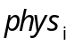 and the physical node 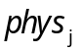. We use the round-trip time of the packet RTT and the packet loss rate PacketLoss to reflect the value of this value, which affects the reliability of the data transmission. and 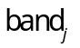 represent the bandwidth of physical node i and physical node j, respectively.  is the average bandwidth of the physical node. We define the migration weight factor as shown in equation (3).
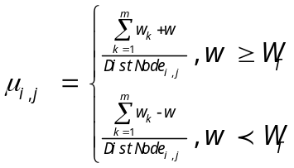 （3）

In Formula 3, 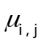 represents the weight update factor of the global task node between  and , and 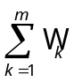 represents the sum of the accumulated task weights from the initial node to the current node through the migration path.w represents the task weight of the current node , and 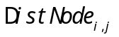 represents the cloud node distance between and . The formula of redefinition of migration weight after improvement is as follows:
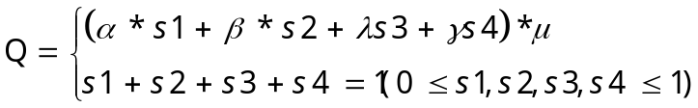 （4）
When multiple mobile agents perform the same task, or when these mobile agents cooperate to process information, there is often cooperation or functional dependency. For example, an agent may depend on other agents in terms of functions. A group of agents may need to run on the same execution environment due to reasons such as sharing of common information resources, collaborative processing of information, and so on.In other cases, due to reasons such as separation of duties and functions and exclusion, some agents may have a mutually exclusive relationship. Therefore, they cannot be migrated to the same information host.Considering these factors, in the migration decision algorithm we designed, the service migration of a group of agents is performed under corresponding different constraint rules, so that each mobile agent is decided to migrate to the corresponding edge node. We set a set of constraint rules R for the groups of agents that make up the edge service. Three types of constraint rules are specified in R:
(1) Atomic rules: a group of agents must migrate to the same platform;
(2) Dependency rule: An agent functionally depends on at least one of several agents; therefore, it must migrate to the same platform as the agent it depends on.
(3) Exclusion rule: Two or more agents cannot be migrated to the same platform.
As shown in Figure 3-3, we deploy a sensing module at each node, update the collected information to the node task weights, then calculate the distance between cloud nodes, and update the weight of the link edges in G through the migration weight coefficient.If there is an edge node directly connected to the current edge node, the destination host with the largest edge weight is added to the temporary migration plan. If there are no direct edges, the Dijkstra shortest path algorithm is used in the undirected graph to obtain the migration path from this node to the destination node and put it into the temporary migration plan.As shown in Figure 3-3, edge node node 1 receives the migration task to migrate to edge node 4, but there is no directly connected edge between the two nodes, and no consensus is established. At this moment, we use the shortest path algorithm to find the path with the greatest benefit (the path node-> noed5-> node4 is the shortest path), and the nodes on this path are all safe nodes that have been verified by mutual trust.If the migration of the node weight exceeds the migration threshold Q_{T}, the node will move to the adjacent maximum weight node. If the migration right of a node does not exceed the migration threshold Q_{T}, the leading node of the migrating node is returned and the currently visited node is identified, then the leading node is a valid node. Calculate the migration weights of all unvisited nodes in G, so continue to iterate until it migrates to the final destination address.Among the multiple optional destination hosts in the migration, according to the three types of constraint rules between a group of agents, the migration plan that does not meet the operating rules is removed from the temporary migration plan. In order to prevent the node from returning to the front node multiple times, a jump threshold Step_{T}is set in the algorithm. If the value returned by the same node exceeds the jump threshold, the migration task ends.（下面的节点图需要重新设计）。

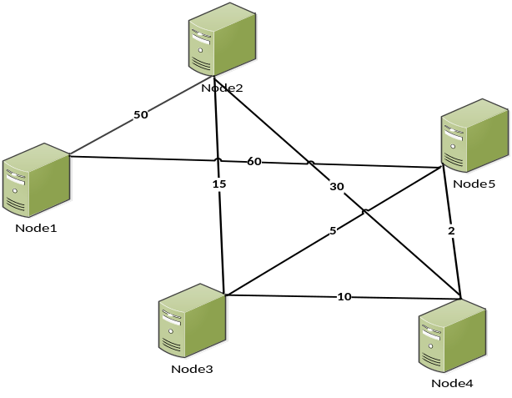
Figure 3-3 Task migration decision algorithm

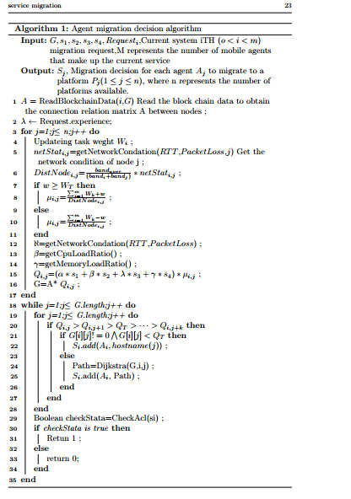

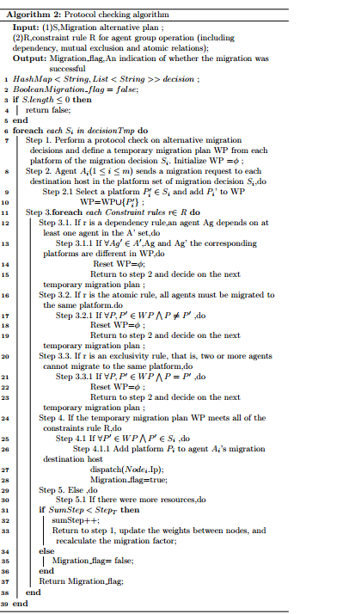

4 Security migration of edge services under the blockchain
In this section, we focus on a secure service migration architecture using blockchain. First, Section 4.1 introduces the security issues of mobile agents and edge services, and describes the huge potential of blockchain in solving the security issues of edge services. In Section 4.2, we present blockchain technology and compare the characteristics of different types of blockchains.Secondly, we introduced the problem description of blockchain technology to solve service migration in Section 4.3, and made a detailed description of the system architecture. In this chapter, we show how to use the blockchain network to ensure that edge service migration is mutual trust and secure Complete the migration in the environment, and introduce the role of each layer. Finally, in Section 4.4, we described the specific details of the blockchain after improving the consensus algorithm.

4.1 Blockchain-based Edge Services Security Migration Practice
Security issues can be divided into two categories: mobile agent security and edge service security. Mobile agent security is to protect the mobile agent from other malicious objects, and mobile agent system security is to protect the mobile agent system from other objects. The object can be a mobile agent or a mobile agent system.Table 4-1 shows the security issues of mobile agents. The table lists the attack types and examples of mobile agents [30]. In the case of mobile agent security, it should basically support confidentiality, integrity, identity verification, access control, and non-repudiation to protect the mobile agent from the aforementioned illegal attacks. Mobile agents are intelligent, autonomous, and adaptive.Especially the mobile agent has mobility, and its mobility is the most significant feature of the mobile agent paradigm [31]. Therefore, the secure migration of mobile agents is considered one of the most important security issues. If an anonymous mobile agent is warned illegally during the migration process, it will cause many serious problems. Therefore, in the mobile agent environment, the integrity of the mobile agent should be guaranteed first.
In addition to the security of mobile agent migration, the security and credibility between the hosts of the edge service migration is also critical.Edge services are located in different edge clouds. Edge servers may belong to different participants, such as telecom operators, Internet companies, and home users. Therefore, it is difficult to resolve the trust in service migration without centralized management of different heterogeneous hardware. problem.The edge computing environment causes data to be sent to an untrusted edge server. There is a security risk. Due to the complex mechanism, the amount of calculation is large and it is difficult to overcome.
The trust problem in service migration in MEC can be solved by blockchain technology with its good performance. Blockchain is a growing list of records, called blocks, which are linked one after the other and are protected using cryptography. It is inherently resistant to data modifications [32,33].The reason is that once recorded, the data in any given block cannot be modified retroactively without changing all subsequent blocks and the network's majority collusion.Therefore, the blockchain can be used as an open and distributed operating system to achieve decentralized consensus. It can effectively record interactions (for example, transactions) between two individuals or agents, and in a verifiable and permanent way.
Table 4-1 Attack Types in Mobile Agent and System
Attacker | Target | Attack type
Mobile Agent | Mobile Agent System | -Camouflage  -Paralysis of mobile agent systems  -Illegal access to resources or services
Mobile Agent | Mobile Agent | -Camouflage  -Interfering with other mobile agents  -Denial of receipt or transmission  -Degeneration of mobile agents
Mobile Agent System | Mobile Agent | -Camouflage  -Tapping status or code of MA  -Altering code or status of MA
Mobile Agent System | Mobile Agent System | -Camouflage  -Illegal accessing services or data  -Illegal message copy or response

4.2 Blockchain
Blockchain is essentially a decentralized database. At the same time, as the underlying technology of Bitcoin, it is a series of data blocks that are generated by using cryptographic methods. Coin network transaction information is used to verify the validity of its information (anti-counterfeiting) and generate the next block [34].Blockchain technology is also a new application model of computer technologies such as distributed data storage, point-to-point transmission, consensus mechanisms, and encryption algorithms. At present, blockchain networks are mainly divided into three categories: public blockchains, private blockchains and alliance chains.

（1）Public Blockchain
The public chain is a completely decentralized blockchain, and any participant can either conduct transactions or read information. Any participant (also known as a miner) can participate in the transaction confirmation and consensus mechanism on the chain. Each node can join or exit the node at any time.
- Private Blockchain
A private chain is a blockchain system that is open to individuals or entities. The authority of each node in the system needs to be assigned by the organization, and the amount of data open to each node should be determined by the organization according to the situation.Although each node is restricted, the private chain is still a multi-node framework of the blockchain. This type of blockchain is more suitable for applications within the organization, such as database management and auditing [35].Private chains have some characteristics. The first is that its transaction speed will be very fast. The transaction speed of private chains is unmatched by other public chains and alliances, mainly because each node does not need to verify a transaction, and a small number of nodes can complete the verification.
- alliance chain

Alliance chain is controlled by multiple centers, and the system is distributed and bookkeeping by several authoritative institutions. These nodes then coordinate their work according to the consensus mechanism. This is a partially decentralized blockchain. Participants can conduct inspections and transactions, but verifying transactions requires internal decisions of the alliance [37].One of the most significant features of the alliance chain is that each node corresponds to an entity institution. Any entity institution node that wants to join the alliance chain needs to obtain permission from the alliance. These institutions work together to maintain the stable development of the system.The participating nodes of the alliance chain are well connected and the verification efficiency is high. This operation can be maintained at the lowest cost and reduces transaction costs while providing high-speed transaction processing [38]. The scalability is good, and the data can maintain privacy to a certain extent.

4.3 System Overview

We use blockchain technology as a carrier, and multiple edge clouds work together to maintain an alliance chain network. The smart contract algorithm deployed in the alliance chain will execute a verification algorithm when each new edge network joins blockchain network.The system framework of the entire trusted network is divided into three layers, namely the audit layer, the edge control layer, and the user layer. As shown in Figure 4-1:

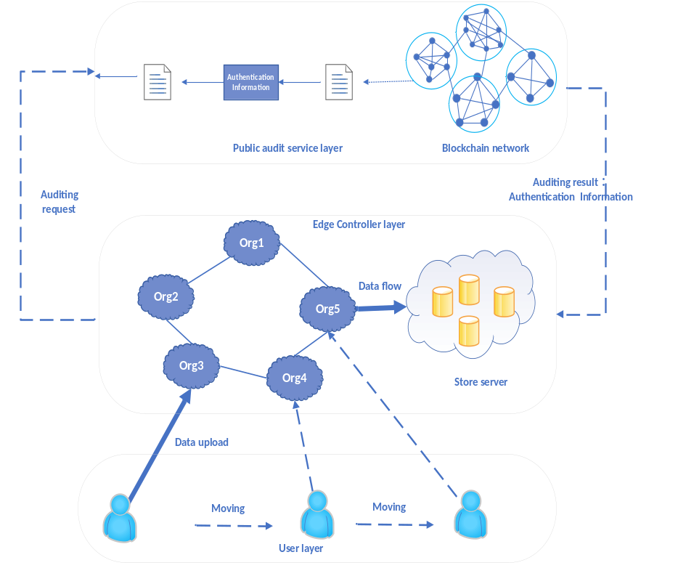
Figure 4-1 Blockchain-based service migration framework

4.3.1 public audit service layer

The first layer is the public audit service layer. In this layer, all edge clouds at different geographical locations jointly maintain a tamper-resistant database to store interaction information of different edge clouds and information of mobile users.They have equal rights in data management and user management. In our system, we have adopted an alliance blockchain to establish a data sharing scheme. The distributed database records the public verification information of different organizations, and each member can verify the integrity of the data without the need for a trusted third party.Therefore, the entire system contains three entities: agents, users, and different edge cloud providers.
(1)Each edge cloud provider, as a separate organization, provides data sharing services for edge nodes. These nodes are able to store and manage the interaction data between edge nodes.In our system, these institutions can be edge servers, routers, switches, integrated access devices (IADs) and other devices close to the terminal.In addition, each institution is considered a alliance blockchain network of blockchain members.In our framework, each institution is a semi-trusted party. Nodes in an organization are trusted,in other words,all nodes in an edge network trust each other, but devices from other organizations are not trusted.This characteristic of the alliance chain is well in line with the situation where there is no centralized management of different heterogeneous hardware in the edge computing environment.
(2)The mobile user is the owner of the data. They belong to different agencies and want to share data through these agencies.
(3）Nodes are controlled by blockchain members. They run several different algorithms to maintain a common ledger that records all verification information.

4.3.2 edge controller layer
The second layer is the edge control layer. This layer is composed of multiple edge clouds and edge nodes, providing end users with rich edge services.As shown in Figure 4-1, for example, five edge clouds Org1, Org2, Org3, Org4, Org5 distributed in different geographical locations establish mutual trust connections with each other. Each cloud provides different Edge services.The function of this layer is to provide diversified edge services (such as real-time data processing in public safety, intelligent connected cars and autonomous driving, VR, industrial IoT, smart home and other applications) and related data storage and management.A more important function is that all members jointly maintain a blockchain database that provides public audit services for users at the third level. Finally, they manage migration scheduling on all edge servers and clusters on the WAN.The edge service scheduler at this layer is responsible for scheduling offload services across edge servers or clusters. The scheduling parameters include but are not limited to the following 4 items.
- the physical location of the edge server.
- performance collection and service migration decisions of the edge server.
- bandwidth and latency perceived by the end user.
- The authentication service is used to verify the identity of the edge server and the end user.

4.3.3 user layer
The third layer is the end user. End users are traditional mobile client Linux mobile devices that run mobile applications on Android, iOS, Windows or other platforms. Users register with the agency and upload the edge services and data they share and use.The migration process of edge services is transparent to end users. Mobile devices can access edge nodes or edge controllers using WiFi or LTE.

4.3.4 Security attributes
Our proposed scheme meets the following security features：
(1)Confidentiality of data. Shared data is not visible to blockchain nodes. In our solution, the blockchain node maintains a blockchain database that records shared data verification information. Nodes should verify the correctness of the shared data, but they should not get real data.
（2）Anonymity. Data owners want to share data without disclosing their true identities because the data may contain personal privacy information. To protect user privacy, data should be shared anonymously.
（3）Traceability. In some cases, when a malicious edge service device attack and tampering occurs, the manager of the edge control layer can track the true identity of the malicious user.
（4）Publicly verifiable. All users can verify the integrity of the shared data without the need for a trusted third party.

4.4 PBFT algorithm
In order to suppress the attacks of malicious edge nodes during the service migration process and avoid blind trust in the integrity guarantee claimed by the cloud provider, the blockchain network we propose is based on the alliance chain.However, the traditional alliance chain mostly adopts the PBFT algorithm as the consensus-based algorithm [39,40]. This algorithm uses a three-phase commit process divided into: pre-prepare, prepare, and commit. As shown in Figure 4-2, the consensus process of the PBFT algorithm in one view can be roughly divided into the following steps:
- The client initiates a consensus request to the master node of the consensus network.
- After receiving the request from the client, the master node broadcasts the request to other replica nodes through the network.
- All replica nodes need to perform a Prepare and Commit process between each other.
- All replicas need to execute the request and reply back to the client.
- Because the maximum number of Byzantines in the network is f, the client needs to wait for f + 1 different nodes to return the same result before it can think that the entire network has reached a consensus.
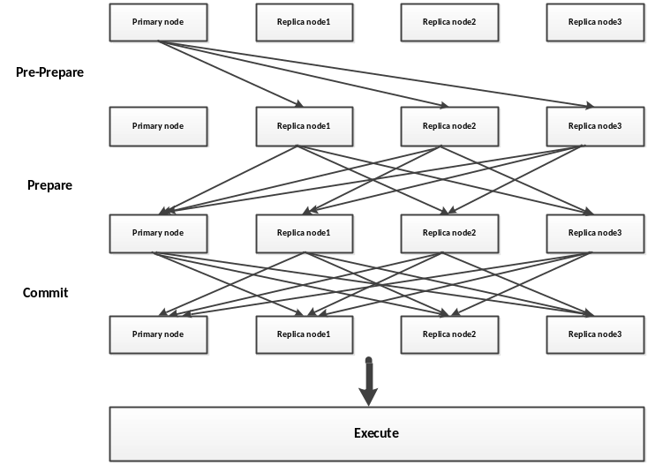
Figure 4-2 PBFT three-phase submission process

4.5Analysis and improvement of PBFT algorithm
From a detailed analysis of the PBFT process, it can be seen that the existing PBFT algorithm has the following deficiencies.
- The client can only send requests to the master node. If there are too many request messages, the master node may be overloaded and the availability will be reduced, which is not suitable for the P2P network environment of the blockchain.
- The checkpoint protocol reduces the overhead of memory in order to solve the problem of certificate information reclamation. The certificate is cleared after regular negotiation through a network-wide consistency process. This process involves a three-phase submission process, which will cause communication waste.
- There is no complete synchronization process for backup data. As time goes by, the data difference between different nodes becomes larger and larger.
To sum up the three reasons, the three-phase commit protocol of PBFT requires a relatively large network transmission and communication overhead, which needs to be further optimized. We use the improved PBFT algorithm (IPBF algorithm). Make the following changes:
（1）Modification of the checkpoint protocol
This paper clears the certificate based on the timestamp of the best block in the blockchain. The improvement we propose is to clear the block from the timestamp of the best block in the blockchain.The blockchain is connected in the form of a linked list according to the generation time of the block, so a certificate before a block timestamp has been verified, and the relevant status of the node has been broadcast and can be cleared.We can listen on the block addition event. When a block is added to the blockchain, the certificate before the block timestamp in the node is cleared. This clearing process does not require nodes to communicate with each other, and it can also ensure that the certificates are cleared in time, thereby reducing communication overhead. Improved blockchain performance, shortened transaction confirmation delays, and increased block throughput.
- Change the client's single point submission request to the master node, and broadcast the signed transaction data to the entire network. This way is more suitable for P2P environment.
(3) Add data synchronization and verification process, and perform data synchronization after the master node election is completed. During synchronization, the slave node verifies the synchronization data. If the verification is passed, the new master node is officially recognized and the next consensus process begins.

5 System performance evaluation
In order to evaluate the performance of the agent migration framework, we propose here some metrics (such as resource usage costs in terms of access and communication latency) to describe the characteristics of the agent-based edge service migration framework.However, since system configuration, agent composition, required resources, and their location are largely related to specific application services, it is difficult to make a conclusive assessment on the intelligent agent platform [42] that constitutes edge services.In addition, changing communication delays, changing network conditions, equipment failures, and resource availability are difficult to consider. Therefore, we use indirect assessments in our assessments, such as mobile agent communication through application-specific web services (face recognition and video parsing services).To assist in the evaluation and application of the mobile agent edge service migration system, we define the relevant factors in each case in Equation 5, and modify the cost to allow the use of different systems and resource configurations to calculate the cost of a particular application.
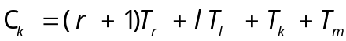 （5）
In Equation 5, we evaluate the maximum delay C in a particular edge service environment k, which includes resource access, execution of agent tasks, and subsequent agent migration delays.Here r is the number of remote resources, Tr is the response time of the static resource request, Tk is the computational overhead in the device, and Tm is the migration delay from sending the proxy message to receiving the confirmation message.Tr is only added once to register the agent with the system. The local resource query delay Tl is generally small and can be ignored, but for large information block retrieval or a large number of local resource accesses l, this is quite considerable.Among them, remote resource query and migration delay are the main factors of these costs.
In Equation 6, we give a specific mobile agent-based edge service. When agents migrate on a completely different network, the total agent migration cost CTotal.Includes additional latency for static resource queries, where s is the number of static resources. The number of heterogeneous networks (3G, 4G, 5G, WI-Fi) is d. Here it is assumed that the agent migrates to each network only once. This equation can be modified to cover different situations.The migration time of the agent between the networks is Tm,d , and we include the delay of possible message conversion in the gateway in Tp. The delay in each execution environment is represented by Cn,t, which can be obtained from Equation 6, where the number of devices running each execution environment is n.
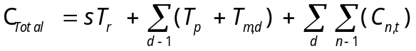 （6）
The cost of latency depends primarily on the number of platforms on which each agent is located in each network and remote resource access. Therefore, in system design and agent composition, remote resources should be considered as static or local resources as much as possible.However, this is a trade-off between proxy migration costs and resource access delays for specific application services, as the combination allows for different resource utilization.In the IOT, we can imagine systems through many different networks, each with its own characteristics and technologies. Therefore, migration costs and resource access delays on heterogeneous networks are important factors in system and application design and deployment phases.

6 Experiment and result analysis
In this section, we will describe the results of experiments and analysis.Under the designed platform simulation, migration experiments were performed on edge services composed of multiple mobile agents to evaluate the effectiveness of the migration algorithm, and compared with the service migration technology based on the docker container.Second, compare the throughput of the improved blockchain by sending batch transactions and creating accounts, and compare the experimental results with Ethereum's unmodified BPFT consensus algorithm.

6.1 lab environment
This research uses some server clusters in the National High Performance Computing Center (Xi'an) of China to simulate the migration framework. The cluster server configuration information is shown in Table 6-1. The cluster includes three types of server nodes with different computing resource configurations to simulate devices with different node performance in the edge network.Among them, the type A server has the highest CPU and memory resource configuration, and the type B server has the lowest CPU and memory resource configuration. The number of A and B servers is 3. Type C servers have medium CPU and memory resources, and the number of servers is 2.
Table 6-1 Experimental equipment list
Server type | TypeA | TypeB | TypeC
Number | 3 | 3 | 2
CPU | 2*Xeon E5430  2.66GHz | 2*Xeon E5310  1.6GHz | 2*Xeon E5410  2.33GHz
Core | 8 | 8 | 8
Memory/GB | 16 | 8 | 8
Storage | 2*146GB SCSI Disk | 146GB SCSI  Disk
Network | 1*100Mbps,1*1000Mbps Ethernet

6.2 experimental design
We developed a prototype system to simulate migrating an edge service consisting of a set of mobile agents from one host to another. The framework uses IBM aglet (aglet, 2016) as a mobile agent development platform. Aglet is a mobile agent program written in pure java language for building mobile agent applications.A mobile agent is an executable program that exists in a specific environment. Once created, it can be deployed, migrated, executed, and eventually destroyed after completing tasks. Technically, the aglet mobile agent can execute on any information host that supports the Java virtual machine. An aglets server (referred to as Tahiti) [44] is installed on a remote host, and it provides any aglet execution environment for the mobile agent to reach the machine.
As mentioned in the previous model, we built an event decision management program (EDS) and resource manager program (RMS), and a data holding management service program (DMS). Finally, we developed a decentralized blockchain trust management Service to simulate trust authorization mechanism.The aglet can communicate with other aglets, and the functional interaction between different agents can use the message interaction method provided by the agent.
In our framework, the migration decision of a service is made by EDS, and a set of services is migrated through an algorithm. Eight mobile agents A1, A2, ..., A8 were created in a service group. As shown in the table below,these agents will be assigned to corresponding information hosts to provide users with edge services.We assume that these 8 agents are initially executing on the same host. The constraint rules of these 8 agents include:
(1) A1 and A2 and A3 are cooperative in information processing and must be migrated to the same information host;
(2) The function of A4 depends on A5 and A6;
(3) For security reasons, A7 and A8 are atomic operations and run separately (data management library service, providing database connection)
Server type | TypeA | TypeB | TypeC
Number | 3 | 3 | 2
Agents | A1,A2,A3 | A4,A5,A6 | A7,A8

6.3 Edge service migration time comparison
In order to compare the efficiency of the migration time of agent-based edge services, we compare with the current advanced docekr container-based migration technology. Docker container migration is developed based on the user-level process checkpoint and recovery tool CRIU (Checkpoint / Restore In Userspace)[19]. We use CRIU to checkpoint processes, freeze running container processes, and then dump state data to the destination host for recovery.A construct called action script is also provided in CRIU, which allows any script to be executed before the container is selected and thawed. We can provide a callback method in the action script to restore the container state. In the test equipment list in Table 6-1, we have 8 servers under the TypeA server list, and the docker container running on each server contains video analysis and face recognition programs.The video parsing and face recognition programs are compared by using mobile agent agent and docker container migration. By using Wondershaper to adjust different bandwidths for testing to simulate different network conditions of edge services. Experimental use cases are as follows:
(1)Face recognition: We designed a face recognition service as an edge service, using OpenCV [45] to identify images. This service can identify the facial attributes (expressions, ages, genders, etc.) of people on pictures by calling api. The identified users are always mobile users, so the dynamic change of mobile computing resources is one of the factors affecting user QoS. In addition, when users move, the quality of service and network conditions change, but they need to maintain ultra-high reliability during communication.
(2)Video stream: Similar to the face recognition program, considering different user needs, user mobility and dynamic network environment, we have prepared video decoding services. It also provides three edge services with different resolutions, high, medium, and low. The resolution of the screen is different under different resolutions, and the decoding requirements are different for different resolutions.When a user moves, the edge device node judges whether to perform task migration according to the quality of service, and a solution for task migration.For example, when a user moves to another edge node and is not sure about a long stay or a short stay, a low-resolution video decoding task may be migrated first. In the case of users staying for a long time, it can provide high-resolution services to avoid untimely migration and waste of resources.
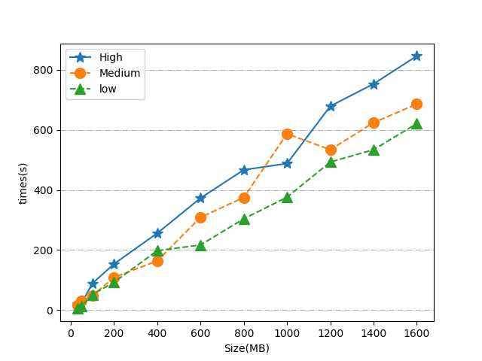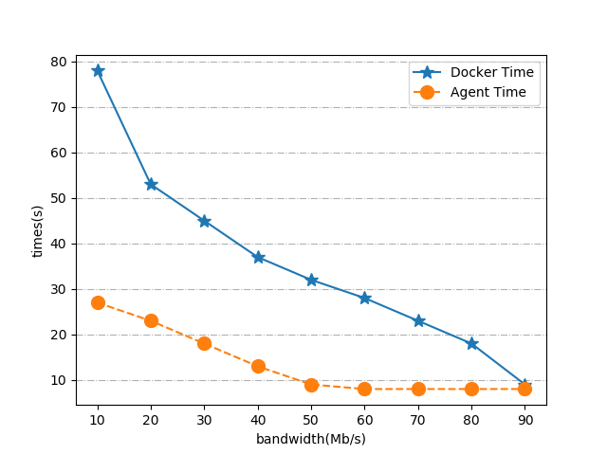
Figure 6-1 Video decoding time comparison under different quality of service Figure 6-2 Comparison of migration time

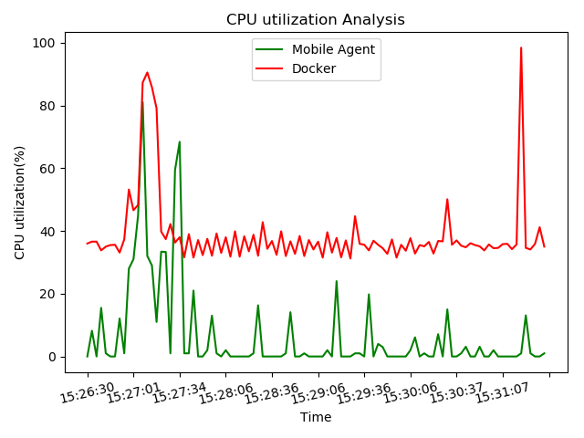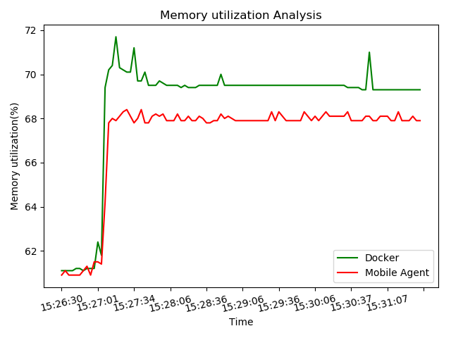
(a)Comparison of CPU usage (b)Comparison of memory usage
Figure 6-3 Comparison of energy consumption between CPU and memory
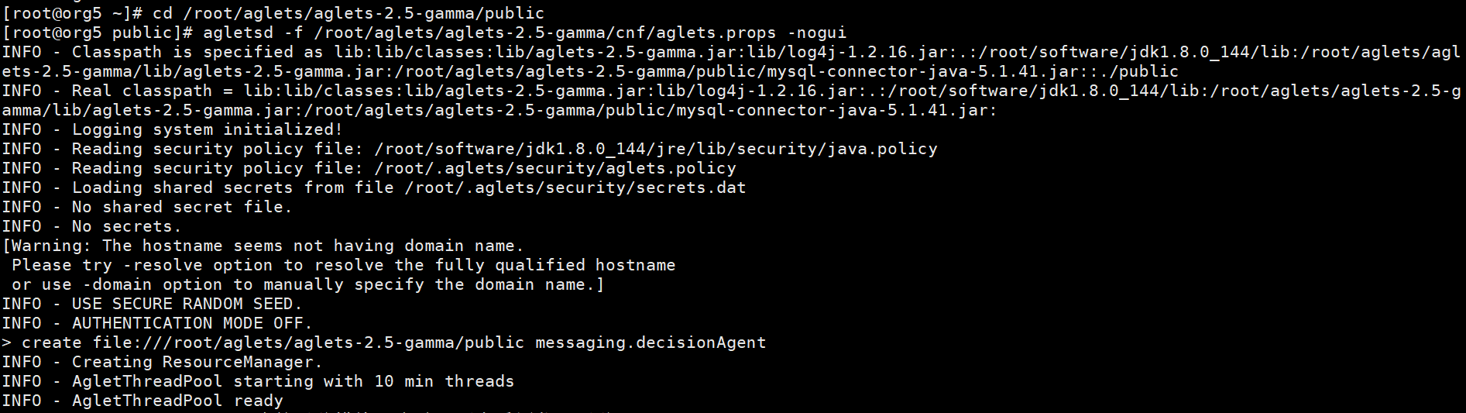
Figure 6-4 (a) Schematic diagram of aglets startup

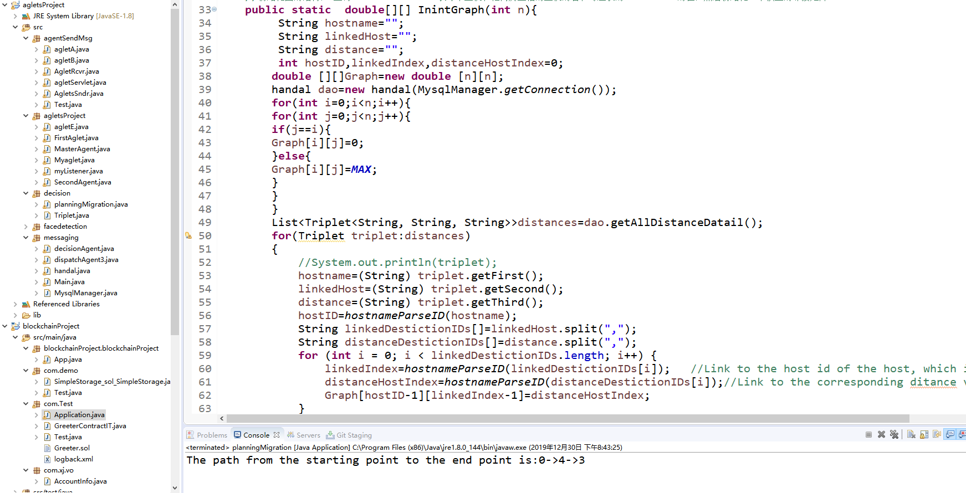
Figure 6-4 (b) Start decision task in Eclipse
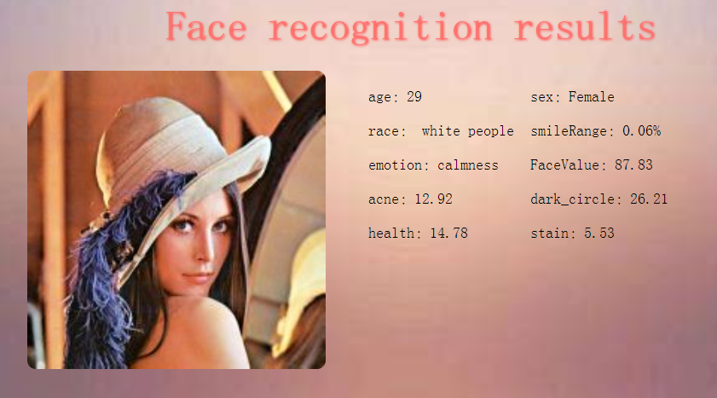
Figure 6-4(c)Face recognition effect
Figure 6-1 is a comparison of decoding time for video files of different sizes under different resolution requirements. The comparison shows that it takes more time to decode a high-resolution, high-quality video. In edge services, we provide users with different service quality video services in different regional network environments.
Figure 6-2 shows the comparison of migration time between edge service based on docker container and facial recognition based on agent. Due to its light weight and its own mobile characteristics, the mobile agent is more suitable as a carrier for edge service migration.The comparison found that agent-based service migration has a shorter migration time than traditional container-based migration. And when the bandwidth reaches a certain limit, the migration time basically stabilizes. In Figure 6-3 (a) (b), we compare the CPU and memory time in the migration process between agent-based service migration and docker container-based service migration. We found that mobile agents are more efficient and costly than docker migration. Fewer computing and memory resources.Figure 6-4 (a) is to start the Aglets system, and run the agents distributed on different nodes to provide services. Figure 6-4 (b) simulates increasing the price load on an edge node in eclispe, which then triggers the migration decision. 6-4 (c) is the face recognition result seen at the target node after starting the migration. The results show that the proxy-based edge service migration framework we designed can make decisions and migrate a group of services to a new edge server based on system conditions, maintaining high QoS.

6.4 Throughput comparison
In order to simulate the mutual trust establishment and smart contract functions of multiple edge cloud service migrations, we used the Ethereum platform to build a secure service migration framework.Ethereum is the best development platform for blockchain. For good performance, this article uses Truffle to test the Ethereum framework, and uses solid language to write smart contracts to implement multiple edge cloud trust verification transactions.Then, run a smart contract on the blockchain. Figure 6-5 shows the process of a security framework building a smart contract.
We introduced the traceability and verification module of the edge cloud joining and leaving process in the blockchain system, and deployed it to the blockchain network after compilation. Then use TestRPC to simulate access to the Ethereum environment in eclispe.Finally, each function of the smart contract was debugged and simulated under the truffle framework, thereby ensuring the security of service migration under multiple edge clouds.

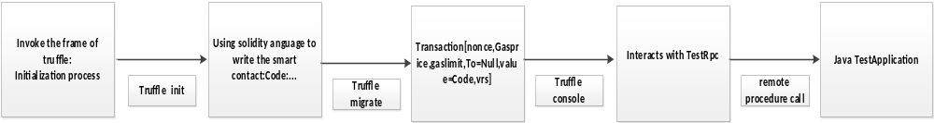
Figure 6-5 Construction of a smart contract

In order to test the throughput of the modified blockchain, we calculate the throughput by creating a different number of accounts and sending the transaction statistics of different times to compare the throughput of the modified block. Specific steps are as follows:
- 8 machines are connected to each other through the Ethereum admin.addPeer(enode) method to form an alliance chain. After starting Ethereum on each node, create an account and address.
(2) We use a nodejs script to create an account and send a request containing a transaction by sending an http request to the blockchain network.The instructions can include parameters such as the number of different transactions. By observing the resource consumption of the system and the TPS performance of the blockchain under different circumstances.The TPS value refers to the number of transactions per second (Transaction Per Second), that is:
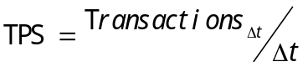
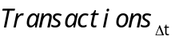 is the number of transactions processed by the system during the block production time, and 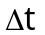 is the block production time. Throughput increases as the capacity of each block increases, but as block capacity increases, consensus time and network load also increase.So when it reaches a certain level, the throughput will decrease. As shown in the figure: when the number of transactions is 7000-8000, the throughput decreases. However, the overall and the original unimproved consensus algorithm's blockchain throughput has been greatly improved, which can meet the mutual trust operation between multiple edge networks.
（3）Through the test script, the number of transaction requests in the http request is gradually increased. Due to the performance problems of the machine, the data obtained after only one test has certain randomness and uncertainty.Therefore, it is necessary to perform a transmission transaction under the condition of 1000-10000, and take the average of the two test results as the TPS performance, and find the average tps value for comparison. The test process is shown in Figure 6-6.
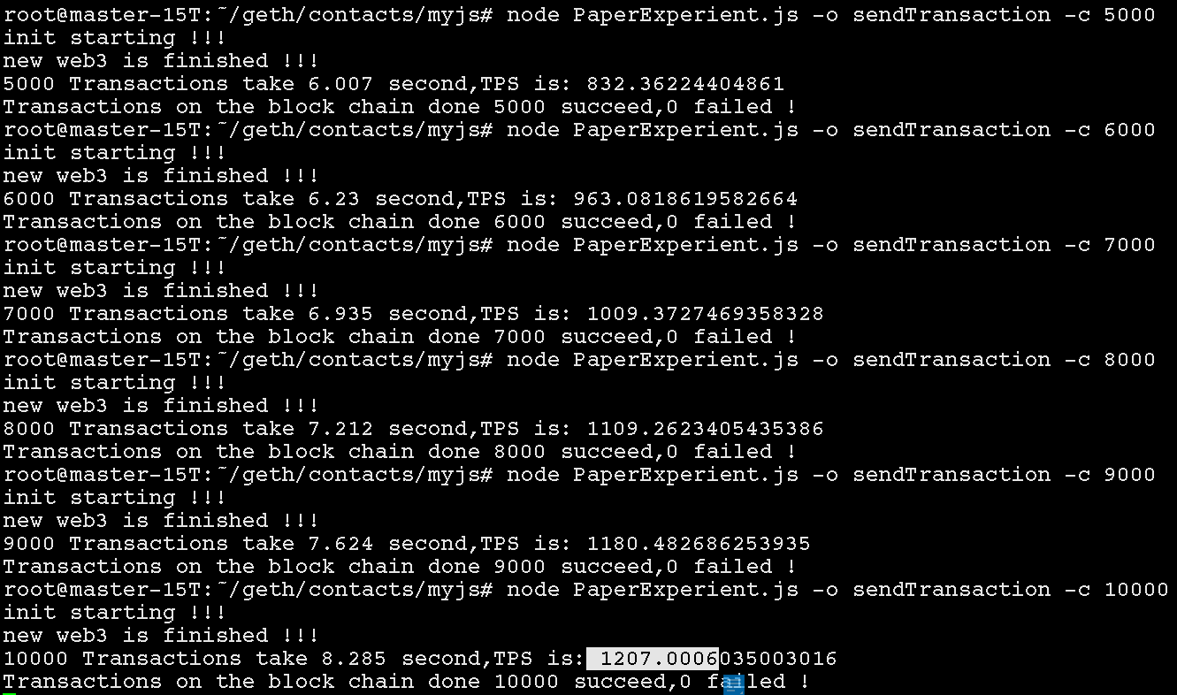

Figure 6-6 Test process
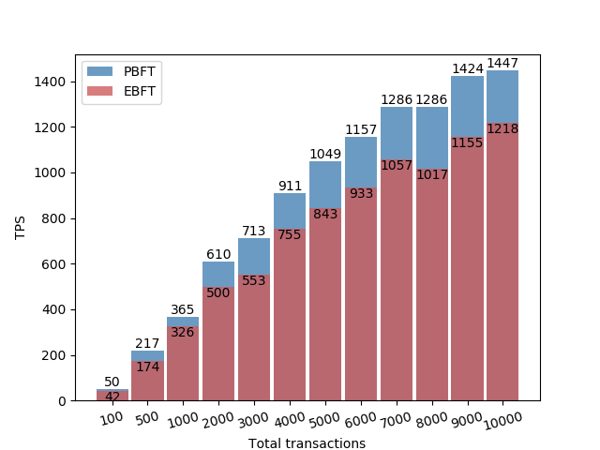 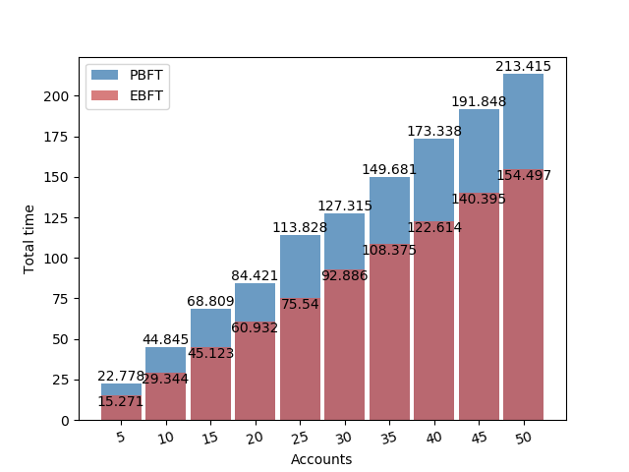 Figure 6-7 (a) Comparison of throughput of sending transactions Figure 6-7 (b) Comparison of throughput of account creation
Figure 6-7 (a) (b) The throughput and time-consuming comparison between the EPBFT blockchain system and the unimproved system after the consensus algorithm is modified to send transactions and create accounts.The comparison found that the blockchain system with improved consensus algorithm has higher throughput.Our method has an average throughput of 23% higher than the alliance chain throughput without improved consensus algorithm. The main reason is that we have changed the policy of clearing certificates after the regular PBFT negotiation, as well as the submission process. This paper clears the certificate based on the timestamp of the best block in the blockchain, thereby improving throughput.It can be seen that using blockchain technology in an edge cloud environment that currently does not have centralized management for different heterogeneous hardware can make MEC's dynamic, open, and collaborative network environment more secure and reliable. Our proposal without a trusted third party is more secure and more suitable for practical applications.

7 conclusion
In this paper, we propose a blockchain-based mobile agent secure edge service migration solution. We use advanced mobile agent technology as a service migration carrier. It is more portable and flexible than the service migration of virtual machines and containers. It cooperates with a group of agents to provide services to users and guarantee good QoS.Secondly, for the trust issue in the service migration process, we use blockchain technology to establish mutual trust, and multiple edge clouds jointly maintain an alliance chain network, providing a reliable migration environment for edge service migration. A secure and reliable service migration is achieved without the need for a trusted audit. To eliminate the requirement for trusted auditing, we store public verification information for auditing in a tamper-resistant database maintained by all participants using blockchain technology.This avoids the trust and secure migration environment guarantee between edge devices without unified management. Any data generated between multiple edge clouds can be recorded by the blockchain, and these data information is unique, so this information can also be queried and traced.When a malicious attack occurs, the data in the blockchain can be tracked to the target device. Through experimental simulation and comparison, our method is more efficient and higher in service quality than docker container-based service migration, and has great potential as a next-generation service migration method.
references：
[1]Christos Stergiou, Kostas E. Psannis, Byung-Gyu Kim, Brij Gupta,
Secure integration of IoT and Cloud Computing,Future Generation Computer Systems,Volume 78, Part 3,2018,Pages 964-975,ISSN 0167-739X,
https://doi.org/10.1016/j.future.2016.11.031.
[2]T. X. Tran, A. Hajisami, P. Pandey and D. Pompili, "Collaborative Mobile Edge Computing in 5G Networks: New Paradigms, Scenarios, and Challenges," in IEEE Communications Magazine, vol. 55, no. 4, pp. 54-61, April 2017.
[3]Sukhpal Singh Gill, Shreshth Tuli, Minxian Xu, Inderpreet Singh, Karan Vijay Singh, Dominic Lindsay, Shikhar Tuli, Daria Smirnova, Manmeet Singh, Udit Jain, Haris Pervaiz, Bhanu Sehgal, Sukhwinder Singh Kaila, Sanjay Misra, Mohammad Sadegh Aslanpour, Harshit Mehta, Vlado Stankovski, Peter Garraghan,Transformative effects of IoT, Blockchain and Artificial Intelligence on cloud computing: Evolution, vision, trends and open challenges,Internet of Things,Volume 8,2019,100118,
ISSN 2542-6605
[4]W. Shi, J. Cao, Q. Zhang, Y. Li and L. Xu, "Edge Computing: Vision and Challenges," in IEEE Internet of Things Journal, vol. 3, no. 5, pp. 637-646, Oct. 2016.doi: 10.1109/JIOT.2016.2579198
[5]Zwolenski M , Weatherill L . The Digital Universe Rich Data and the Increasing Value of the Internet of Things[J]. Australian Journal of Telecommunications & the Digital Economy, 2014, 2(3).
[6]Y. Mao, C. You, J. Zhang, K. Huang and K. B. Letaief, "A Survey on Mobile Edge Computing: The Communication Perspective," in IEEE Communications Surveys & Tutorials, vol. 19, no. 4, pp. 2322-2358, Fourthquarter 2017.
doi: 10.1109/COMST.2017.2745201
[7] S. Wang, R. Urgaonkar, M. Zafer, T. He, K. Chan and K. K. Leung, "Dynamic service migration in mobile edge-clouds," 2015 IFIP Networking Conference (IFIP Networking), Toulouse, 2015, pp. 1-9.doi: 10.1109/IFIPNetworking.2015.7145316
- Cheol-Ho Hong and Blesson Varghese. 2019. Resource Management in Fog/Edge Computing: A Survey on Architectures, Infrastructure, and Algorithms. ACM Comput. Surv. 52, 5, Article 97 (September 2019), 37 pages. DOI: https://doi.org/10.1145/3326066
[9]H. Li, G. Shou, Y. Hu and Z. Guo, "Mobile Edge Computing: Progress and Challenges," 2016 4th IEEE International Conference on Mobile Cloud Computing, Services, and Engineering (MobileCloud), Oxford, 2016, pp. 83-84.
doi: 10.1109/MobileCloud.2016.16
[10]Min Chen, W. Li, G. Fortino, Y. Hao, L. Hu, I. Humar, "A Dynamic Service-Migration Mechanism in Edge Cognitive Computing", ACM Transactions on Internet Technology, Vol. 19, No. 2, Article 30, 2019.
[11] Z. Gao, Q. Jiao, K. Xiao, Q. Wang, Z. Mo and Y. Yang, "Deep Reinforcement Learning Based Service Migration Strategy for Edge Computing," 2019 IEEE International Conference on Service-Oriented System Engineering (SOSE), San Francisco East Bay, CA, USA, 2019, pp. 116-1165.
[12]V. De Nitto Personè and V. Grassi, "Architectural Issues for Self-Adaptive Service Migration Management in Mobile Edge Computing Scenarios," 2019 IEEE International Conference on Edge Computing (EDGE), Milan, Italy, 2019, pp. 27-29.
doi: 10.1109/EDGE.2019.00020
[13]N. Abbas, Y. Zhang, A. Taherkordi and T. Skeie, "Mobile Edge Computing: A Survey," in IEEE Internet of Things Journal, vol. 5, no. 1, pp. 450-465, Feb. 2018.doi: 10.1109/JIOT.2017.2750180
[14]A. Machen, S. Wang, K. K. Leung, B. J. Ko and T. Salonidis, "Live Service Migration in Mobile Edge Clouds," in IEEE Wireless Communications, vol. 25, no. 1, pp. 140-147, February 2018.
[15]W. Lu, X. Meng and G. Guo, "Fast Service Migration Method Based on Virtual Machine Technology for MEC," in IEEE Internet of Things Journal, vol. 6, no. 3, pp. 4344-4354, June 2019.
doi: 10.1109/JIOT.2018.2884519
[16]Gang Sun, Dan Liao, Vishal Anand, Dongcheng Zhao, Hongfang Yu,
A new technique for efficient live migration of multiple virtual machines,
Future Generation Computer Systems,
Volume 55,2016,Pages 74-86,ISSN 0167-739X,
https://doi.org/10.1016/j.future.2015.09.005.
[17]L. F. Bittencourt, M. M. Lopes, I. Petri and O. F. Rana, "Towards Virtual Machine Migration in Fog Computing," 2015 10th International Conference on P2P, Parallel, Grid, Cloud and Internet Computing (3PGCIC), Krakow, 2015, pp. 1-8.
doi: 10.1109/3PGCIC.2015.85
[18]L. Ma, S. Yi, N. Carter and Q. Li, "Efficient Live Migration of Edge Services Leveraging Container Layered Storage," in IEEE Transactions on Mobile Computing, vol. 18, no. 9, pp. 2020-2033, 1 Sept. 2019.
doi: 10.1109/TMC.2018.2871842
[19]CRIU. (2017) Criu. [Online]. Available: https://criu.org/Main_Page
[20]S. Alami-Kamouri, G. Orhanou and S. Elhajji, "Overview of mobile agents and security," 2016 International Conference on Engineering & MIS (ICEMIS), Agadir, 2016, pp. 1-5.
doi: 10.1109/ICEMIS.2016.7745371
[21]Aglets(2016).Aglets User Manual. Available at http://aglets.sourceforge.net.Akuma, S., Iqbal, R., Jayne, C., & Doctor, F. (2016). Comparative analysis of relevance feedback methods based on two user studies. Computers in Human Behavior, 60,138–146.
[22]Yanjun Zuo, Jigang Liu,A reputation-based model for mobile agent migration for information search and retrieval,International Journal of Information Management,
Volume 37, Issue 5,2017,Pages 357-366,ISSN 0268-4012,
https://doi.org/10.1016/j.ijinfomgt.2017.04.002.
- M. G. R. Alam, Y. K. Tun and C. S. Hong, "Multi-agent and reinforcement learning based code offloading in mobile fog," 2016 International Conference on Information Networking (ICOIN), Kota Kinabalu, 2016, pp. 285-290.
doi: 10.1109/ICOIN.2016.7427078
[24]Alami-Kamouri S , Orhanou G , Elhajji S . Mobile Agent Service Model for Smart Ambulance[C]// International Conference on ICT Infrastructures and Services for Smart Cities International Conference on Cloud Networking for Internet of Things Systems. 2018.
[25]Y. Zuo and J. Liu, "Mobile Agent-Based Service Migration," in 2015 12th International Conference on Information Technology - New Generations (ITNG), Las Vegas, NV, USA, 2015 pp. 8-13.
doi: 10.1109/ITNG.2015.7
[26]M. Metzger and G. Polakow, "A Survey on Applications of Agent Technology in Industrial Process Control," in IEEE Transactions on Industrial Informatics, vol. 7, no. 4, pp. 570-581, Nov. 2011.
doi: 10.1109/TII.2011.2166781
[27]Desai, Prashant & Jayakumar, Naveenkumar. (2017). A Survey on Mobile Agents. International Journal for Research in Applied Science and Engineering Technology. V. 2915-2919. 10.22214/ijraset.2017.11401.
- Desai, Prashant & Jayakumar, Naveenkumar. (2017). A Survey on Mobile Agents. International Journal for Research in Applied Science and Engineering Technology. V. 2915-2919. 10.22214/ijraset.2017.11401.
[29]Niu Haichun and Liu Yong, "A mobile agent-based task seamless migration model for mobile cloud computing," 2014 IEEE Workshop on Advanced Research and Technology in Industry Applications (WARTIA), Ottawa, ON, 2014, pp. 241-246.
doi: 10.1109/WARTIA.2014.6976242
[30]Belghiat, Aissam, Elhillali Kerkouche, Allaoua Chaoui and Mokhtar Beldjehem. “Mobile Agent-Based Software Systems Modeling Approaches: A Comparative Study.” CIT 24 (2016): 149-163.
[31]Rui Wang, Yong Cao, Adeeb Noor, Thamer A Alamoudi, Redhwan Nour,
Agent-enabled task offloading in UAV-aided mobile edge computing,
Computer Communications,Volume 149,2020,Pages 324-331,ISSN 0140-3664,
https://doi.org/10.1016/j.comcom.2019.10.021.
[32]Changsong Yang, Xiaofeng Chen, Yang Xiang,
Blockchain-based publicly verifiable data deletion scheme for cloud storage,Journal of Network and Computer Applications,Volume 103,2018,
Pages 185-193,ISSN 1084-8045,
https://doi.org/10.1016/j.jnca.2017.11.011.
- Huang Hui, Chen XiaoFeng, Wang Jianfeng, Blockchain-based multiple groups data sharing with anonymity and traceability, SCIENCE CHINA Information Sciences, https://doi.org/10.1007/s11432-018-9781-0.
- ui Zhang, Rui Xue, and Ling Liu. 2019. Security and Privacy on Blockchain. ACM Comput. Surv. 52, 3, Article 51 (July 2019), 34 pages. DOI: https://doi.org/10.1145/3316481
- Huang, Hui & Li, Kuan-Ching & Chen, Xiaofeng. (2018). Blockchain-based fair three-party contract signing protocol for fog computing. Concurrency and Computation: Practice and Experience. e4469. 10.1002/cpe.4469.
- Gaetani, Edoardo et al. “Blockchain-Based Database to Ensure Data Integrity in Cloud Computing Environments.” ITASEC (2017).
- C. Nguyen, Dinh & Pathirana, Pubudu & Ding, Ming & Seneviratne, Aruna. (2019). Integration of Blockchain and Cloud of Things: Architecture, Applications and Challenges.
- S. Huh, S. Cho and S. Kim, "Managing IoT devices using blockchain platform," 2017 19th International Conference on Advanced Communication Technology (ICACT), Bongpyeong, 2017, pp. 464-467.
doi: 10.23919/ICACT.2017.7890132
- Amritraj Singh, Reza M. Parizi, Qi Zhang, Kim-Kwang Raymond Choo, Ali Dehghantanha,Blockchain smart contracts formalization: Approaches and challenges to address vulnerabilities,Computers & Security,Volume 88,2020,101654,ISSN 0167-4048,
https://doi.org/10.1016/j.cose.2019.101654.
- K. Zheng, Y. Liu, C. Dai, Y. Duan and X. Huang, "Model Checking PBFT Consensus Mechanism in Healthcare Blockchain Network," 2018 9th International Conference on Information Technology in Medicine and Education (ITME), Hangzhou, 2018, pp. 877-881.
doi: 10.1109/ITME.2018.00196
- H. Sukhwani, J. M. Martínez, X. Chang, K. S. Trivedi and A. Rindos, "Performance Modeling of PBFT Consensus Process for Permissioned Blockchain Network (Hyperledger Fabric)," 2017 IEEE 36th Symposium on Reliable Distributed Systems (SRDS), Hong Kong, 2017, pp. 253-255.
doi: 10.1109/SRDS.2017.36
- S. Sasirekha and S. Swamynathan, "Cluster-chain mobile agent routing algorithm for efficient data aggregation in wireless sensor network," in Journal of Communications and Networks, vol. 19, no. 4, pp. 392-401, August 2017.
doi: 10.1109/JCN.2017.000063
- P. Mach and Z. Becvar, "Mobile Edge Computing: A Survey on Architecture and Computation Offloading," in IEEE Communications Surveys & Tutorials, vol. 19, no. 3, pp. 1628-1656, thirdquarter 2017.
doi: 10.1109/COMST.2017.2682318
- R. S. Chowhan, A. Mishra and A. Mathur, "Aglet and kerrighed as a tool for load balancing and scheduling in distributed environment," 2016 International Conference on Recent Advances and Innovations in Engineering (ICRAIE), Jaipur, 2016, pp. 1-6.
doi: 10.1109/ICRAIE.2016.7939531
- Aglets(2018).Opencv User Manual. Available at https://docs.opencv.org/4.2.0/d9/df8/tutorial_root.html(2018).

